Cairo University  
Faculty of Computers and Information



**CS251**

**Software Engineering I**

Project Name

Software Requirements Specifications

Team Names

Month & Year

Contents

Instructions [To be removed] 4

Team 4

Document Purpose and Audience 4

Introduction 4

Software Purpose 4

Software Scope 5

Definitions, acronyms, and abbreviations 5

Requirements 5

Functional Requirements 5

Non Functional Requirements 5

System Models 6

Use Case Model 6

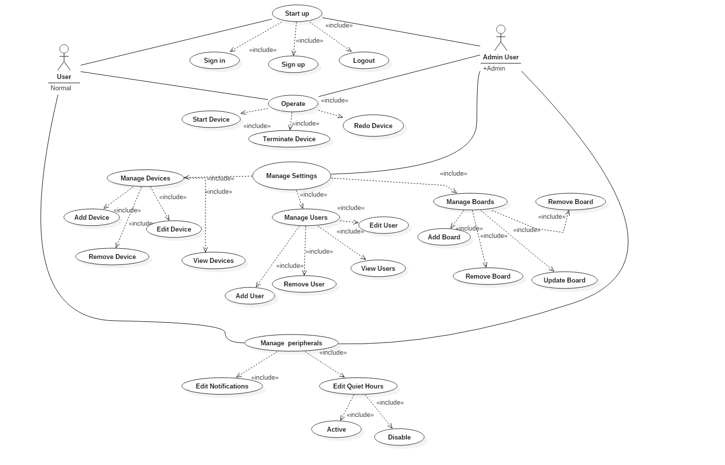 7

Use Case Tables 7

Ownership Report 17

# Instructions [To be removed]

* **IMPORTANT. Rename this document to CS251-LeaderID-SRSDocument.docx**

**(e.g. CS251-20040752-SRSDocument.docx)**

* **Remove the following notes and any red notes.**
* **This document is the template document for your SRS.**

# Team

|  |  |  |  |
| --- | --- | --- | --- |
| **ID** | **Name** | **Email** | **Mobile** |
| 20146016 | Ismail Sherif Moustafa |  | 01156596754 |
| 20146011 | Mahmoud Samy Saeed |  |  |
| 20146013 | Hager Mohamed Sobeah |  | 01202590820 |
| 20146018 | Donia Khaled Ahmed |  |  |
| 20146009 | Safwa Mohamed Hussein |  |  |

# Document Purpose and Audience

* **This is document for SHCS (Smart Home Control System) Software and it describes the functionality of the software using diagrams.**
* **This document targets CEO, Project Manager and Customer.**

# Introduction

## Software Purpose

A Smart home control system (SHCS) is a system which is controlled by a mobile phone application or a web application, and at the same time controls, monitors and coordinates home appliances such as air conditioner, microwave oven, garage doors, TV , indoor/outdoor lights, home security system, etc. In order to activate home appliances and to allow use of home appliances, the SHCS needs mechanisms for communication between the different devices in the system, and for coordination among the various processes running on such devices.

## Software Scope

* **SHCS Software will be available on Android Devices and as Web App.**
* **SHCS Software will only monitor devices through using sensors.**
* **SHCS will only have the ability to start and terminate devices connected within it.**
* **Users will have the ability to add/remove devices on SHCS.**

## Definitions, acronyms, and abbreviations

NULL

# Requirements

## Functional Requirements

* The User has to sign in to start using the App.
* The User has to create board and invite other users to it.
* The User can add, remove, edit and view devices.
* The User can operate on a specific device connected to SHCS.
* The User can check the status for each connected device.
* The User can manage various settings such as notifications, boards, etc...

## Non Functional Requirements

* **Usability** 
  + The User has to sign in to access his board.
  + The User can create more than one board.
* **Adaptability**
  + Any change is environment will be detectable, and the SHCS then take actions on different home appliances.
* **Reliability** 
  + SHCS will save all user details within his boards in case the system broken down.
  + SHCS will backup data automatically every 15 mins.
* **Performance** 
  + SHCS will be able to manage and operate more than 10 devices at the same time.
  + SHCS would start in 200msec.
  + SHCS will update the status of each device automatically and give the user a report through notifications every 20 mins.
* **Security** 
  + Each Device connected to the SHCS has an id which returns to specific user, so no one can access any device and board except its owner.
* **Scalability**
  + SHCS will be able to manage up to 20 devices on each board.

# System Models

## Use Case Model

## 

## Use Case Tables

|  |  |  |
| --- | --- | --- |
| Use Case ID: | 1 | |
| Use Case Name: | Sign in | |
| Actors: | Admin User/User | |
| Pre-conditions: | User starts App | |
| Post-conditions: | User Sign in the app successfully | |
| Flow of events: | **User Action** | **System Action** |
| 1- User Enter Card and Password. |  |
|  | 2- System check user data |
| 3- User sign in successfully |  |
| Exceptions: | **User Action** | **System Action** |
| 1- User Enter e-mail and Password. |  |
|  | 2- e-mail or password is incorrect.  3- System rejects entry. |
| Includes: |  | |
| Notes and Issues: |  | |

|  |  |  |
| --- | --- | --- |
| Use Case ID: | 2 | |
| Use Case Name: | Sign up | |
| Actors: | Admin User/User | |
| Pre-conditions: | User starts App | |
| Post-conditions: | User Sign up for the app successfully | |
| Flow of events: | **User Action** | **System Action** |
| 1- User Enter e-mail and Password and other details. |  |
|  | 2- System verify data. |
| 3- User sign up successfully |  |
| Exceptions: | **User Action** | **System Action** |
| 1- User Enter e-mail and Password and other details. |  |
|  | 2- System verify data.  3- System rejects entry. |
| Includes: |  | |
| Notes and Issues: |  | |

|  |  |  |
| --- | --- | --- |
| Use Case ID: | 3 | |
| Use Case Name: | Logout | |
| Actors: | Admin User/User | |
| Pre-conditions: | User starts App | |
| Post-conditions: | User logouts from the app successfully | |
| Flow of events: | **User Action** | **System Action** |
| 1- User presses logout button. |  |
|  | 2- System allow the user to logout and save a backup for his data. |
| Exceptions: | **User Action** | **System Action** |
| 1- User presses logout button. |  |
|  | 2- System fails to save a backup. |
| Includes: | NULL | |
| Notes and Issues: | NULL | |

|  |  |  |
| --- | --- | --- |
| Use Case ID: | 4 | |
| Use Case Name: | Add Device | |
| Actors: | Admin User | |
| Pre-conditions: | Admin User press manage devices button. | |
| Post-conditions: | Admin User add a device successfully. | |
| Flow of events: | **User Action** | **System Action** |
| 1- User Press Add button. |  |
|  | 2- System starts searching for the device. |
| 3- Admin User confirm that the addition of the device. |  |
|  |  | 4- SHCS connect the device onto the board |
| Exceptions: | **User Action** | **System Action** |
| 1- User chooses a device. |  |
|  | 2- System fails to connect the device. |
|  | 1- User search for an unsuitable device. |  |
|  |  | 2- System tries to connect the device but every time it fails. |
| Includes: | NULL | |
| Notes and Issues: | NULL | |

|  |  |  |
| --- | --- | --- |
| Use Case ID: | 5 | |
| Use Case Name: | Remove Device | |
| Actors: | Admin User | |
| Pre-conditions: | Admin User press manage devices button. | |
| Post-conditions: | Admin User removes a device successfully. | |
| Flow of events: | **User Action** | **System Action** |
| 1- User Presses Remove Device button. |  |
| 2- User select needed device to be removed |  |
|  | 3- SHCS removes the device and saves data for this device for future usage. |
| Exceptions: | **User Action** | **System Action** |
| 1- User chooses a unavailable device. |  |
|  | 2- System fails to remove the device. |
| Includes: | NULL | |
| Notes and Issues: | NULL | |

|  |  |  |
| --- | --- | --- |
| Use Case ID: | 6 | |
| Use Case Name: | Edit Device | |
| Actors: | Admin User | |
| Pre-conditions: | Admin User press manage devices button. | |
| Post-conditions: | Admin User edit a device successfully. | |
| Flow of events: | **User Action** | **System Action** |
| 1- Admin User Press Edit button. |  |
| 2- Admin User chooses a device to edit. |  |
| 3- Admin User edits the device. |  |
|  |  | 4- SHCS update the device details. |
| Exceptions: | **User Action** | **System Action** |
| 1- Admin User chooses a device. |  |
| 2- Admin User make an unsuitable change in details. |  |
|  |  | 3- System fails to update device details |
| Includes: | NULL | |
| Notes and Issues: | NULL | |

|  |  |  |
| --- | --- | --- |
| Use Case ID: | 7 | |
| Use Case Name: | View devices | |
| Actors: | Admin User / User | |
| Pre-conditions: | Admin User / User press view devices button. | |
| Post-conditions: | Admin User / User views all devices connected to SHCS on current board. | |
| Flow of events: | **User Action** | **System Action** |
| 1- User Press View devices button. |  |
|  | 2- System shows up all devices connected at the current time |
| Exceptions: | **User Action** | **System Action** |
| NULL |  |
| Includes: | NULL | |
| Notes and Issues: | NULL | |
| Use Case ID: | 8 | |
| Use Case Name: | Run device | |
| Actors: | Admin User / User | |
| Pre-conditions: | Admin User / User press Run device button. | |
| Post-conditions: | Admin User / User run a device successfully. | |
| Flow of events: | **User Action** | **System Action** |
| 1- User Press Run button. |  |
|  | 2- System starts to make the device run. |
| Exceptions: | **User Action** | **System Action** |
| 1- User Press Run. |  |
|  | 2- System fails to start up the device. |
| Includes: | NULL | |
| Notes and Issues: | NULL | |

|  |  |  |
| --- | --- | --- |
| Use Case ID: | 9 | |
| Use Case Name: | Terminate Device | |
| Actors: | Admin User / User | |
| Pre-conditions: | Admin User / User press terminate device button. | |
| Post-conditions: | Admin User terminates a device successfully. | |
| Flow of events: | **User Action** | **System Action** |
|  | NULL |  |
| Includes: | NULL | |
| Notes and Issues: | NULL | |

|  |  |  |
| --- | --- | --- |
| Use Case ID: | 10 | |
| Use Case Name: | Redo Device | |
| Actors: | Admin User / User | |
| Pre-conditions: | Admin User press Redo device button. | |
| Post-conditions: | Admin User restart a device successfully. | |
| Flow of events: | **User Action** | **System Action** |
| 1- User Press Redo button. |  |
|  | 2- System restart the device. |
| Exceptions: | **User Action** | **System Action** |
|  | NULL |  |
| Includes: | NULL | |
| Notes and Issues: | NULL | |

|  |  |  |
| --- | --- | --- |
| Use Case ID: | 11 | |
| Use Case Name: | Edit Notification | |
| Actors: | Admin User / User | |
| Pre-conditions: | Admin User / User press Edit Notification button. | |
| Post-conditions: | Admin User / User edits his(her) notification successfully. | |
| Flow of events: | **User Action** | **System Action** |
| 1- User Presses Edit Notification button. |  |
|  | 2- System updates notification details. |
| Exceptions: | **User Action** | **System Action** |
|  | NULL |  |
| Includes: | NULL | |
| Notes and Issues: | NULL | |

# Ownership Report

|  |  |
| --- | --- |
| **Item** | **Owners** |
|  |  |
|  |  |